WORK PROCEDURE
Update: _2026.January_

Documents shredding
Secured shredding
Shredding of outdated archive

_ Congratulations for your decision to dispose of - through secure shredding - unnecessary, outdated documents. etc.

_To begin with, you need to send an email to office(@)distrugere(.)ro with a request for an Offer. - It is advisable to specify at least the general location (city/sector/neighborhood) and the estimated quantity in kg of documents to be shredded.

_ You will receive by e-mail: the Offer form, the standard Contract for the provision of shredding services, the standard Takeover-Collection Protocol, as well as other details requested by you.

_If you agree with the Offer items, please contact us, preferably by phone, 0767.966.595, to establish the exact location, date and time from where the documents will be collected for shredding. - Before we come to you to collect the archive, it is necessary to indicate your UIC/TIN number so that we can fill in the forms.

_If the quantities/volumes of documents to be shredded are significant, it will be necessary to send us some photos via email or WhatsApp, or even, prior to collection, for a team from us to come to your location in order to assess the situation and optimize the document collection process.

_!ATTENTION ! The shredding procedure is IREVERSIBILE !
- Be very careful about what kind of documents you hand over for secure shredding, because it cannot be restored, the procedure being irreversible.

_We do not do archival processing, we do not extract documents from your archive, only you decide what kind of documents you destroy. - We only take kilograms/tons of documents for shredding and the hand-over-reception protocol reflects this. - If it is useful to you, behind the hand-over-reception protocol, you can have an inventory where you can enter the type/category of documents, but from our point of view → we shred quantities of documents, we are not interested in their quality, and the content of these documents is your responsibility, these issues are also specified in the Shredding Services Agreement.

_At the location where the documents are picked up, they will also be electronically weighed (we will bring a large-capacity electronic scale), and the quantity in kg will be entered in the pick-up report.

_ Knowing exactly the kilograms that need to be shredded, we issue you an Invoice, which is sent via email and through
e-Factura system.

_ After we collect the invoice payment, the shredding of your documents will begin.

_Before the actual shredding, your documents are separated from metal items, plastic items, protective films, etc. are removed, so that the resulting cross-cut paper waste does not have metal or plastic impurities. - Waste resulting from the shredding of your documents is handed over, free of charge, to companies specialized in waste management.

_ After the shredding is completed – the Shredding Certificate / Activity Report, standard form, will be sent by e-mail.

_As you are noticed in the Offer received by email, the grid of fees is dynamic, meaning that the price decreases as the quantity for shredding increases.
- The price of our services is calibrated in order to include all specific operations, after entering into a contractual relationship:

electronic weighing at your location, pick-up based on take-over-reception protocol, loading, transportation, unloading, preparation for shredding, disposal of plastics, actual shredding, bagging of the resulting waste, handing over the waste to a certified recycler (free of charge), other incidental operations etc.

_We are constantly concerned about sustainability and care for the environment, thus, all waste resulting from document shredding is recycled and reintroduced into the economic circuit. - Thus, together with you, we are part of the circular economy.

_The circular economy is a model of production and consumption that involves sharing, renting, reusing, repairing, refurbishing and recycling existing materials and products for as long as possible. This extends the life cycle of the products. In practice, it involves minimizing waste. When a product reaches the end of its life cycle, the materials from which it is made are kept in the economy as much as possible by recycling. They can be used in production again and again, creating even more added value.
It is an approach that differs radically from the traditional, linear economic model based on the principle "use-produce-consume-throw away". This traditional model is based on large quantities of cheap and easily accessible materials and energy.

_Advantages: Why we need to move to a circular economy?
_Environmental protection_ Reusing and recycling products will slow the depletion of natural resources, will mitigate the impact on landscapes and natural habitats, and will help limit biodiversity loss.
_ Another benefit of the circular economy is the decrease in total annual greenhouse gas emissions. According to the European Environment Agency, industrial processes and product consumption are responsible for 9.10% of greenhouse gas emissions in the EU, and waste management for another 3.32%.
_Reducing dependence on raw materials_The world's population is growing and so is the demand for raw materials. However, the available supply of essential raw materials is limited. The finite supply also means that some EU countries are dependent on other countries for their raw material supplies. According to Eurostat, the EU imports around half of the raw materials it consumes.
_Recycling raw materials also reduces supply risks, such as price volatility, availability and import dependency. This is particularly true for essential raw materials needed to produce technologies that are crucial to achieving climate goals, such as batteries and electric engines.
_ Jobs and savings for consumers_ The transition to a more circular economy can increase competitiveness, boost innovation, encourage economic growth and job creation (700,000 jobs in the EU alone by 2030).

_ More information on the circular economy:
→ Commission website for the new Circular Economy Action Plan
→ EPRS infographic on the circular economy

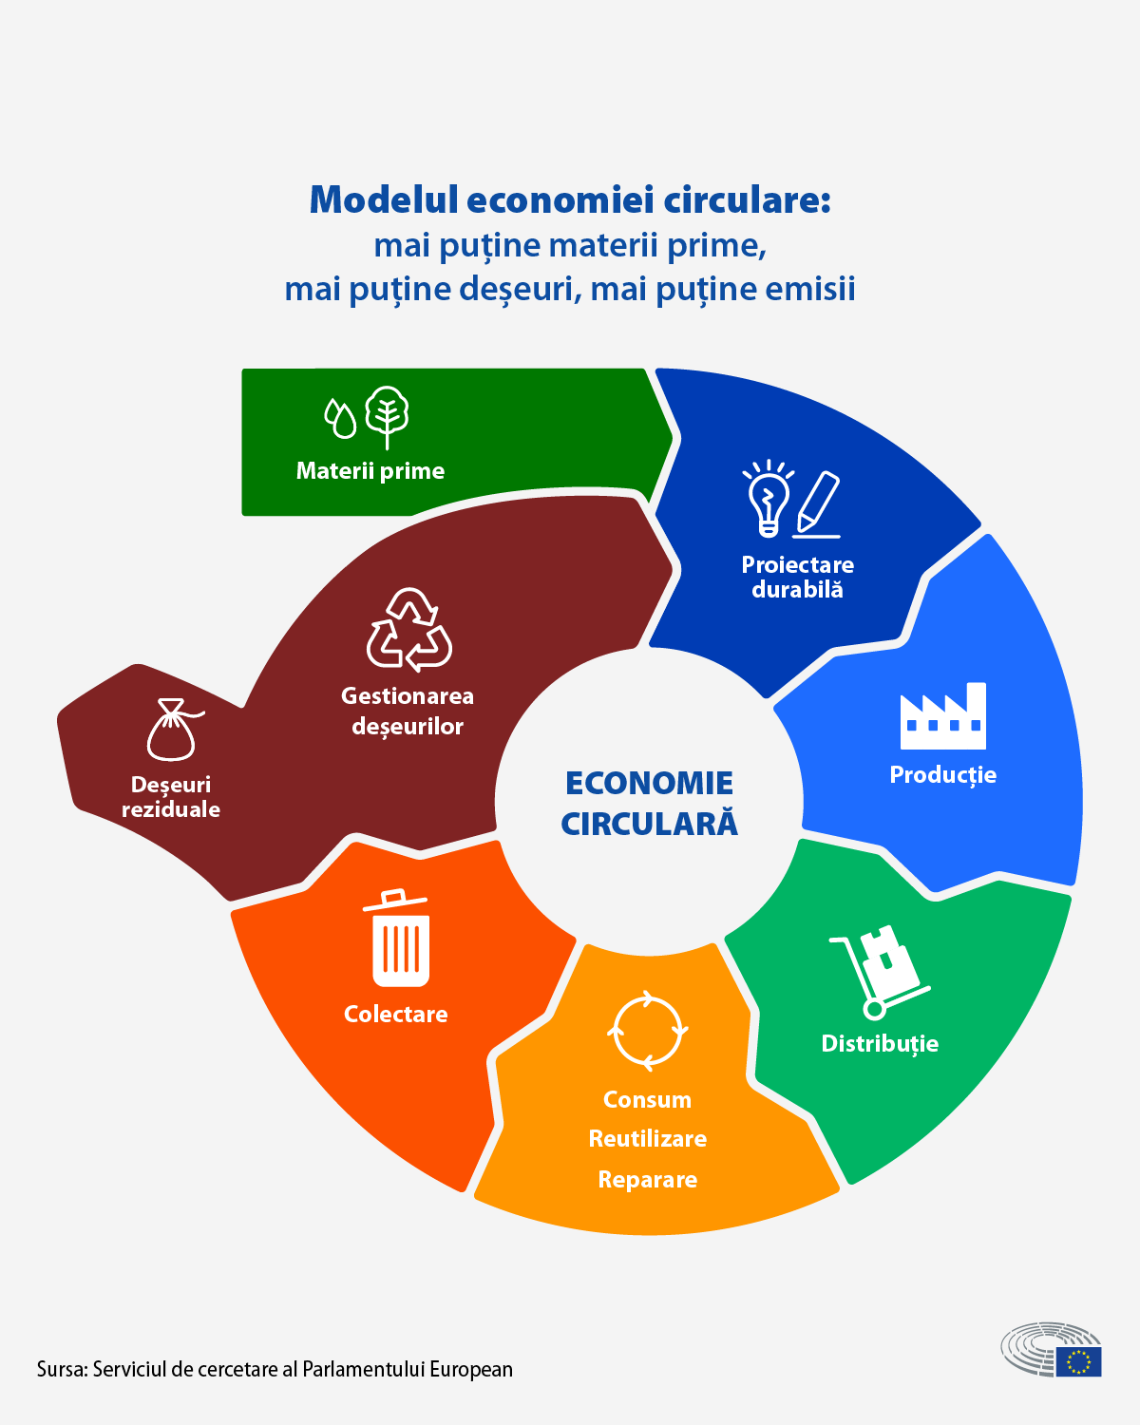
Circular economy – less raw materials, less wastes, less emissions

__ For requests for offers regarding document shredding, secure, irreversible and confidential shredding of documents and archives, contact us by e-mail at: office(@)distrugere(.)ro or by phone: 0767.966.595
Kind regards,
Distrugere(.)ro Team

